## CHAPTER ONE

## INTRODUCTION

## 1.1 Background of the Study

Fires are destructive and often unpredictable disasters that can result in devastating consequences for human lives and valuable properties. One of the key challenges in fire safety is the ability to detect fires in their early stages, enabling prompt intervention and evacuation. Smoke detection systems have emerged as crucial tools in fire prevention, playing a vital role in safeguarding lives and properties. Smoke is a complex mixture of particles and gases produced during the incomplete combustion of various materials. It is categorized into two main types: visible and invisible smoke. Visible smoke consists of tiny particles that can be seen with the naked eye, while invisible smoke comprises odorless and potentially toxic gases, often responsible for the majority of fire-related fatalities (National Fire Protection Association, 2019).

Smoke detectors are specialized devices designed to detect the presence of smoke particles in the air. They are indispensable components of fire detection systems and are instrumental in alerting occupants and authorities to potential fire hazards. Smoke detectors are available in various types, including ionization smoke detectors and photoelectric smoke detectors. Ionization detectors are particularly sensitive to invisible smoke particles, while photoelectric detectors are effective at detecting visible smoke.

In recent times, Nigeria has witnessed several fire incidents that have resulted in loss of lives and extensive property damage. One such incident occurred in Agege, a suburb of Lagos State, where two residential buildings were engulfed in flames, causing injuries and significant destruction. Such incidents underscore the urgent need for robust fire prevention and detection mechanisms to mitigate the impact of fires on lives and properties.

Smoke detection systems are crucial for early fire detection and prevention. Smoke detectors identify smoke particles before flames are visible, allowing timely intervention, evacuation, and activation of fire suppression systems, potentially saving lives and reducing damage. These systems benefit not only homes but also commercial spaces, industries, and educational institutions, enhancing fire safety and compliance with regulations. Advancing technology offers innovative solutions, including our study's focus on an Arduino-based smoke detector and reporting system. This project utilizes Arduino Uno microcontrollers, GSM modules, and smoke sensors to enhance fire safety measures, contribute to early detection, and prevent fire-related disasters.

## 1.2 Statement of Problem

## Fires are very essential and useful in various ways, but can cause devastating disasters that could result to loss of lives and valuable property if not properly and effectively managed. One of the primary issues lies in the timeliness and reliability of early warning mechanisms designed to detect smoke and potential fire outbreaks. Traditional smoke detectors, while effective, may have limitations in terms of their coverage area, sensitivity to varying types of smoke, and the speed at which they can transmit real-time alerts to relevant parties (Mubashar *et al*, 2020). The conventional smoke detection systems often require manual monitoring and maintenance, which can be resource-intensive and susceptible to human error. Regular inspections, battery replacements, and calibration are necessary to ensure the proper functioning of these systems, and any lapses in maintenance could compromise their reliability precisely when they are needed the most (Suh *et al*, 2020). This challenge becomes more significant in large and complex buildings where multiple smoke detectors are installed, making it difficult to manage and ensure the operational readiness of each unit.

These challenges highlight the pressing need for an advanced and automated smoke detection and reporting system that can overcome the limitations of existing solutions.

## 1.3 Aim and Objectives of the Study

The aim of this study is to design and construct a smoke detection and reporting system.

The objectives of this project are as follows:

1. To carry out a study on existing smoke detection systems.
2. To design and construct a smoke detection system using Arduino Uno microcontrollers
3. To integrate GSM modules with the smoke detection system.
4. To evaluate the performance and reliability of the developed system.

**1.4 Scope of the Study**

This study focuses on the design and implementation of a smoke detection and reporting system, with a primary focus on enhancing fire safety measures in residential and small-scale commercial environments.

## 1.5 Justification of the Study

This study is underscored by the critical need for effective fire safety measures and early detection systems as delayed response to fires can lead to loss of lives and property. The system aims to enhance fire safety by providing an early warning mechanism for the presence of smoke. Early detection enables prompt evacuation and intervention, potentially minimizing injuries and property damage. Timely alert generation, the integration of GSM modules allows for real-time reporting of smoke detection to relevant stakeholders, including property owners, emergency services, and users. This ensures that appropriate actions are taken promptly.

## 1.6 Outline of Project

## Chapter one is the introduction of the research topic which includes the background of the study, statement of the problem, aim and objectives, scope and justification of the study.

Chapter two:is the literature review. It gives an introduction of the topic and review of some related works.

Chapter three:is the research methodology. The chapter discussed the method used in collecting data for the study, respondents of the study and the data analysis.

Chapter four:is the result and discussion. It starts with an introduction followed by the discussion of the different results generated.

Chapter five:is the conclusion and recommendations. The chapter starts with an introduction followed by summary and lastly some recommendations and future research.

**CHAPTER TWO**

**LITERATURE REVIEW**

**2.1 Introduction to Fire and Fire Alarm Systems**

Fire is a self-sustaining, chemical chain reaction with varying degrees of light and heat. Temperature and smoke sensing alert system is motivated to sense the temperature and smoke and send the alert in an intelligent fashion in case of emergency situation due to fire blow. In every country in the world the fire alarming system is considered to be essential for lots of physical structures including industries, shopping malls and private houses (NFPA, 2022).

Fire is made up of four components: Fuel, Oxygen, Heat, Chemical Chain Reaction. By removing one of these four components the fire will go out. Fire extinguishers are designed to do just that. There is a universal system to describe different types of fires. This system incorporates the use of letters, colors and symbols to help users select an extinguisher suitable for the type of material involved in the fire.

1. **Class A**: Ordinary combustibles, such as wood, cloth, paper, rubber, many plastics, and other common materials that burn easily.
2. **Class B**: Flammable liquids. Includes gasoline, oil, grease, tar, oil-based paint, lacquer, and flammable gas.
3. **Class C**: Electrical equipment, such as wiring, fuse boxes, circuit breakers, machinery and appliances.
4. **Class D**: Combustible metals. Includes magnesium, aluminum, lithium, and other combustible metals or metal dust.

Smoke detection systems stand as crucial cornerstones within fire safety strategies, providing the vital capability to promptly identify potential fire outbreaks and facilitate swift intervention. These systems have traversed a trajectory of advancement, integrating modern technologies to elevate their efficiency and efficacy in averting fire related calamities (Mishra *et al,* 2020). The core principle underlying these systems revolves around the early detection of smoke particles often precursors to fires triggering alarms that enable swift responses and actions to mitigate potential hazards.

Historically, smoke detection systems employed ionization or photoelectric sensors, but technological progress has ushered in more sophisticated mechanisms capable of distinguishing diverse types of smoke and environmental conditions. This evolution has embraced microcontrollers like the Arduino Uno and communication modules like GSM, ushering in real-time reporting and remote monitoring capabilities (Kim *et al,* 2020). These advancements not only enhance detection precision but also facilitate seamless integration into broader building management frameworks and emergency response protocols. Amid recent fire incidents, particularly within Nigeria, the exigency for robust fire safety measures has been underscored, magnifying the urgency and impact of developing advanced smoke detection and reporting systems as proposed in this study. By blending innovation with these technologies, the study aspires to bolster fire safety practices and reduce the ramifications of fire related crises.

## 2.2 Review of Fundamental Concepts

**2.2.1** **Smoke Detection Principles**

Smoke detection systems are designed to detect the presence of smoke particles generated during the early stages of combustion. Smoke particles contain a mixture of solid and liquid aerosols suspended in the air, and their identification is pivotal in preventing fires from escalating. Two primary smoke detection principles are widely employed:

1. **Ionization Detection:** Ionization smoke detectors operate based on the ionization of air particles by ionizing radiation from a small radioactive source. The ionized air facilitates electrical conductivity between two charged plates, and when smoke particles disrupt this conductivity, an alarm is triggered (NFPA, 2022). This type of detector is sensitive to fast-flaming fires and is commonly found in residential settings due to its affordability. However, concerns about the radioactive source and the potential for false alarms from non-smoke particles have led to the exploration of alternative detection methods (Iqbal *et al*, 2020).
2. **Photoelectric Detection:** Photoelectric smoke detectors offer a modern approach to smoke detection by utilizing light scattering principles. These detectors consist of a light source emitting a focused beam across a sensing chamber. When smoke particles enter the chamber, they scatter the light onto a photoelectric sensor placed to detect changes in light intensity. This scattered light triggers the sensor to activate an alarm, making photoelectric detectors particularly effective in detecting slow, smoldering fires that produce visible smoke (ASTM, 2019). One advantage of photoelectric detection is its reduced susceptibility to false alarms from dust or steam, unlike ionization detectors. The method's sensitivity to larger smoke particles and its focus on visible smoke make it valuable in residential settings and environments prone to smoldering fires. However, optimal performance often involves integrating photoelectric detectors with other methods, showcasing the dynamic evolution of smoke detection technology to enhance fire safety (Kim *et al,* 2020).

## 2.2.2 Technological Advancements in Smoke Detection

Recent advancements have revolutionized smoke detection systems, enhancing their accuracy, responsiveness, and integration capabilities. Traditional ionization and photoelectric sensors have been augmented by more sophisticated options, such as dual-sensor detectors that combine the strengths of both technologies (Abduh *et al*, 2021). Moreover, advanced sensors have emerged, capable of distinguishing between different types of smoke, such as fast-burning and smoldering fires, thereby reducing false alarms (Kim *et al*, 2020). These advancements have also been facilitated by the integration of wireless communication technologies and the Internet of Things (IoT). Smoke detectors can now be interconnected through wireless networks, enabling real-time data sharing and remote monitoring (Li *et al*, 2019). This interconnectedness allows for faster response times, as alerts can be immediately transmitted to homeowners, building managers, or even fire departments. Additionally, mobile applications and cloud-based platforms offer users the convenience of monitoring and managing their smoke detection systems remotely, providing valuable insights and control over fire safety measures (Nadeem *et al*, 2020). The emergence of smart homes and building automation systems has further driven the integration of smoke detection into broader home management frameworks. Smoke detectors can now interact with other smart devices, such as fire suppression systems, ventilation systems, and lighting controls, to create a comprehensive fire safety ecosystem (Iqbal *et al*, 2020). This integration ensures a more coordinated response to fire emergencies and enhances the overall safety of occupants.

## 2.2.3 Role of Microcontrollers in Smoke Detection

Microcontrollers, like the Arduino Uno, have significantly contributed to the evolution of smoke detection systems. These compact computing devices provide processing power, connectivity, and programmability, enabling the integration of various sensors, communication modules, and decision-making algorithms (Bennett *et al,* 2019). By interfacing with smoke sensors, microcontrollers process sensor data and trigger appropriate responses, such as sounding alarms or sending alerts via communication modules like GSM (Mishra *et al,* 2020). The Arduino Uno, for instance, offers a versatile platform for building smoke detection systems due to its ample input/output pins, analog-to-digital converters, and communication interfaces (Sharma *et al,* 2020). The microcontroller can receive analog signals from smoke sensors and employ programmed threshold values to determine smoke density levels. When these levels exceed a certain threshold, the microcontroller activates the alarm system, notifies relevant stakeholders through communication modules, and even initiates actions like turning on exhaust fans or sprinklers in advanced systems. Figure 2.1 below shows the Arduino uno microcontroller board layout.

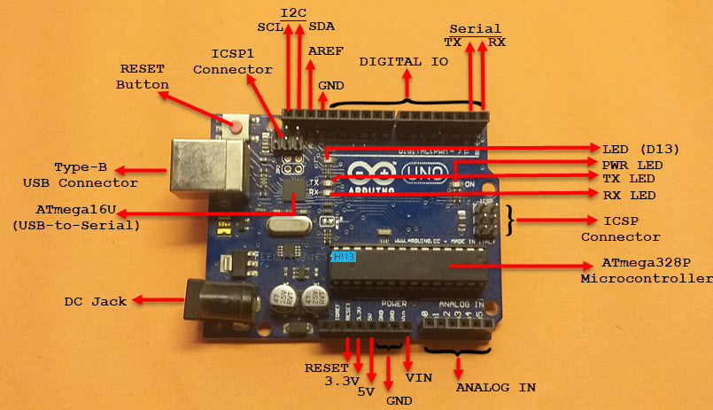

Figure 2.1: Arduino UNO Microcontroller Board Layout [https://www.electronicshub.org]

## 2.2.4 GSM Modules for Real-Time Reporting

GSM modules offer a crucial communication link in modern smoke detection systems. By leveraging cellular networks, these modules enable real-time reporting of fire incidents, allowing stakeholders to receive instant alerts and take swift actions (Chakraborty *et al*, 2019). Through SMS notifications, email alerts, or cloud-based platforms, GSM modules enhance remote monitoring and contribute to the timeliness of emergency response efforts (Mugadza *et al*, 2020). GSM modules integrated with microcontrollers, such as the Arduino Uno, enable seamless data transmission and enable users to remotely access information about the status of the smoke detection system (Kumar *et al*, 2020). When the smoke sensor detects abnormal levels of smoke, the microcontroller processes the data and triggers the GSM module to send notifications to designated individuals or emergency services. This immediate reporting mechanism ensures that appropriate actions can be taken promptly to prevent the escalation of fire incidents.

Furthermore, GSM modules facilitate scalability and adaptability by supporting communication through multiple channels, including voice calls, short message service (SMS), and mobile applications (Agrawal *et al*, 2019). This versatility ensures that stakeholders receive alerts in a manner that aligns with their preferences and availability. The integration of GSM modules into smoke detection systems underscores the pivotal role of modern communication technologies in enhancing fire safety and reducing response times.

## 2.2.5 Role of Arduino Kits in Smoke Detection Systems

Arduino kits, featuring microcontrollers like the Arduino Uno, have become indispensable tools in the development of modern smoke detection systems. These kits provide a versatile platform for integrating various components, such as sensors, actuators, communication modules, and user interfaces (Gomes *et al.*, 2019). The programmability of Arduino microcontrollers allows for customization and the implementation of complex algorithms for data analysis and decision-making.

In smoke detection systems, Arduino kits serve as the central processing unit, receiving data from smoke sensors and other peripherals. The microcontroller processes the incoming data to determine the presence of smoke and triggers appropriate actions, such as sounding alarms or activating communication modules for real-time reporting (Arya *et al.*, 2020). The ease of use and wide community support associated with Arduino kits make them accessible to both novices and experienced developers, enabling rapid prototyping and deployment of smoke detection solutions.

**2.3 Review of Related Works**

Arduino Uno microcontrollers have gained prominence as versatile platforms for developing innovative solutions, including fire detection and reporting systems. Arduino Uno, powered by the ATMega328 microcontroller, offers a user-friendly interface and extensive connectivity options, making it suitable for integrating various sensors and communication modules (Handoko, 2019). The simplicity of Arduino programming and its compatibility with a wide range of hardware components make it an attractive choice for building robust fire safety systems. The MQ-2 smoke sensor is a critical element in smoke detection systems, designed to identify hydrocarbon gases and smoke particles. The MQ-2 sensor's high sensitivity and rapid response contribute to early detection, providing valuable time for evacuation and fire suppression activation (Ramady *et al,* 2020). This type of sensor is well-suited for applications in both residential and commercial environments.

The integration of Internet of Things (IoT) services further enhances the capabilities of smoke detection systems. IoT allows for remote data collection, real-time monitoring, and cloud-based reporting (Wilianto and Kurniawan, 2020). This connectivity enables efficient management of fire safety systems across multiple locations and facilitates timely alerts and interventions.

In the context of Nigeria, recent fire incidents highlight the urgent need for effective smoke detection and reporting systems. Fires in public places and residential areas have led to injuries, property damage, and loss of life (Imtiaz *et al*., 2019; Zhang *et al*., 2020). Implementing robust fire safety measures, including advanced smoke detection systems, is crucial to mitigating the impact of such incidents.

**Karwan *et al* (2022)** presented a mobile fire alarm system based on wireless sensor networks, focusing on the efficient detection and reporting of fire incidents. The system utilized sensor nodes to detect smoke and temperature changes and communicated the data wirelessly to a central monitoring station. This work highlighted the significance of rapid data transmission for timely intervention.

**Mahzan *et al* (2020)** introduced an Arduino-based home fire alarm system with a GSM module. The system integrated smoke detection sensors and GSM technology to send real-time alerts to homeowners and emergency services in case of fire emergencies. The study emphasized the importance of a reliable communication module in ensuring swift response to fire incidents.

**Vivek *et al* (2023)** developed a forest fire detection system using a combination of sensors, including those for smoke, CO, and CO2 concentrations. The system aimed to monitor forested areas and detect fires at their early stages. This work showcased the potential of multisensory integration for comprehensive fire detection.

**Adamu (2020)** focused on the development of a "Testing and Construction of Fire Alarm" system, wherein a thermistor was utilized as the heat sensor. This thermistor exhibited a characteristic behavior wherein its resistance decreased as the temperature increased, and vice versa. At normal temperatures, the resistance of the thermistor (denoted as TH1) hovered around 10K, but as temperatures exceeded 1000°C, the resistance dropped significantly to just a few ohms. The circuit design employed easily accessible components and could be conveniently assembled on a general-purpose vero-board. The core component, IC1, was an operational amplifier configured as a comparator.

The thermistor (acting as the sensor) was connected to the input pin 2 of the comparator, while a fixed reference voltage was applied to pin 3. This comparator continually compared the input voltage with the reference voltage. When the input voltage surpassed the reference voltage, the output at pin 6 would go high. Conversely, when the reference voltage exceeded the input voltage, the output would go low. A low output signal indicated that the load was disconnected, whereas a high output signal indicated that the load was engaged. The primary purpose of the constructed fire detection system was to identify the presence of fire and emit an audible alarm to alert occupants about potential fire hazards. However, these detectors displayed a limitation they could only trigger alarms once the fire had already ignited, rendering the system somewhat unreliable. To address this reliability concern, smoke detectors were introduced. Unlike the traditional fire detectors, smoke detectors were capable of providing alarms promptly without the delay associated with fire detectors. The crucial goal of such detection systems is to prevent fires from occurring or to minimize their impact. This is achieved through accurate and early detection, which is pivotal for safeguarding both lives and property.

**Irawan *et al* (2021)** presented a study focusing on smoke detection using the MQ-2 sensor and Arduino Uno microcontroller. The research explored the integration of Internet of Things (IoT) services for real-time reporting and remote monitoring. The study's emphasis on IoT highlighted the importance of modern connectivity solutions in enhancing fire safety systems.

This study aims to leverage the capabilities of Arduino kits, smoke sensors, and GSM modules to develop an innovative smoke detector and reporting system. By incorporating these technologies and building upon existing research, the project seeks to contribute to fire prevention efforts and enhance emergency response strategies. These related works collectively underscore the significance of reliable smoke detection, real-time reporting, and advanced technology integration in fire safety systems. The findings and methodologies of these studies provide valuable insights that guide the development and implementation of the proposed smoke detector and reporting system using Arduino kits and GSM modules.

## 2.4 Existing Smoke Detection Systems

Currently, there are a variety of smoke detection systems within the market. They use a different model of matched transmitter and receiver to attain excellent stability of frequency for signal transmission (Smith, 2020). Whether using photoelectric or ionization chambers, the vital element is sensitivity to discover the presence of smoke (Johnson, 2019). Some of them have inbuilt fixed and rate-of-rise heat detectors (Brown & Clark, 2018). Straight-down and side-view configurations of video cameras are available alongside glass-break detectors and panic transmitters (Jones et al., 2021). Furthermore, low standby current on sleep mode will save power (White, 2017). There is a replacement model that operates at very high sensitivity (Miller & Harris, 2020).

The system adopts an 'artificial intelligence' patent called Classifier (Anderson, 2019). It ensures that the system operates at the most safe sensitivity to allow warning of issues sooner than previously considered potential. Classifier also controls dirt filter monitoring to prevent partial preventive measures that reduce system performance (Hill, 2018). The system can be connected to the computer, and detailed chart recordings of historical smoke levels showing date, time, and alarm thresholds can be viewed (Davis & Allen, 2019).

Apart from that, technological improvements in microprocessor use in fire alarm systems have led to the development of new smoke detector concepts (Peters, 2020). These new sensors use analog technology to measure the conditions within the space or house protected and transmit that data to the computer-based fireplace alarm control unit (Gray & Turner, 2019). This new device will report when it's too dirty to perform properly or it's getting too sensitive due to any number of conditions in the protected space (Lewis et al., 2018). Analog sensors provide an essentially false-alarm-free system from conditions commonly found in buildings (Smith & Johnson, 2021). This detector technology also allows the system designer to adjust the sensor's sensitivity to accommodate the atmosphere or use an extra-sensitive setting to safeguard a high-value or mission-sensitive area (Brown et al., 2020).

In addition, there is another technique used to find smoke which is gas-sensing fire detectors (Hill & Davis, 2017). Many changes occur in the gas content of the environment during a fire (Peters & Gray, 2021). In large-scale fire tests, it has been observed that detectable levels of gases are reached after detectable smoke levels and before detectable heat levels (Anderson & White, 2019). One of two operating principles such as semiconductor and catalytic principle may be employed in a gas-sensing fire detector (Lewis, 2018). Fire-gas detectors of the semiconductor type respond to either oxidizing or reducing gases by making electrical changes within the semiconductor (Jones & Miller, 2019). The subsequent conduction changes of the semiconductor trigger the detector (Davis, 2018). Meanwhile, fire-gas detectors of the catalytic type contain a material that remains unchanged but accelerates the chemical reaction of flammable gases (Harris, 2018). The resulting temperature rise within the part causes detector effort (Clark & Turner, 2017).

## 2.4.1 Analysis of Existing Smoke Detection System

The effectiveness of smoke detection and reporting systems is evident in their ability to provide early warnings, prompt intervention, and real-time reporting in the event of fire incidents. While various systems have been designed to fulfill this critical role, analyzing an existing system can offer valuable insights into the strengths and limitations of current approaches.

One example of an existing smoke detection system is the conventional ionization smoke detector. This system operates by ionizing air particles through ionizing radiation from a radioactive source. When smoke disrupts the conductivity between two charged plates, an alarm is triggered. While ionization detectors are efficient at detecting fast-burning fires, they may have limitations in accurately detecting smoldering fires, potentially leading to false alarms or delayed responses (Heskestad and Björn, 2019). On the other hand, photoelectric smoke detectors utilize light beams to identify smoke particles. These detectors emit a light beam, and when obstructed by smoke particles, the scattered light triggers an alarm signal. Photoelectric detectors excel in detecting smoldering fires but may have reduced sensitivity to fast-burning fires (Wu *et al*, 2019).

Furthermore, advancements in smoke detection systems have introduced dual-sensor detectors that combine ionization and photoelectric technologies. These detectors aim to provide more accurate and reliable detection across various fire scenarios. Additionally, innovative sensors have emerged, capable of distinguishing between different types of smoke particles, contributing to reducing false alarms and enhancing detection accuracy (Vemula and Kumar, 2020). While these systems demonstrate advancements in smoke detection, challenges still exist. Existing systems may not always consider the specific environmental conditions and the diversity of fire scenarios. Furthermore, real-time reporting capabilities may be limited, impacting the speed of emergency response. Addressing these challenges can lead to the development of more robust and responsive smoke detection and reporting systems.

## 2.4.2 Disadvantages of Existing Smoke Detection System

1. False Alarms: Traditional ionization smoke detectors can trigger false alarms due to sensitivity to activities like cooking or steam, causing unnecessary panic (Zhang and He, 2019).
2. Limited Smoke Differentiation: Ionization detectors may struggle to differentiate between various types of smoke, potentially leading to delayed response in critical situations (Zhang and He, 2019).
3. Slow Response to Rapid Fires: Photoelectric smoke detectors might be less responsive to rapidly spreading fires, resulting in delayed alerts and evacuation (Zhu *et al*, 2021).
4. Sensitivity to Dust and Debris: The effectiveness of photoelectric detectors can be compromised by dust or debris accumulation, reducing their sensitivity over time (Zhu *et al,* 2021).
5. Local Alarms: Both ionization and photoelectric detectors rely on local alarms that may not reach individuals in different parts of a building, limiting their effectiveness in larger structures or remote locations.

The development of an advanced smoke detection and reporting system using Arduino kits and GSM modules aims to address these limitations, providing real-time reporting, remote monitoring, and improved accuracy in detecting various fire scenarios.

## CHAPTER THREE

## METHODOLOGY

## In this chapter, the materials and methods employed in the development of the Smoke Detection and Alert System using Arduino kits and GSM modules will be comprehensively discussed. The chapter provide insights into the components and tools utilized in the project, the design and implementation process, as well as the testing and evaluation methods employed. The systematic presentation of materials and methods will shed light on how the research objectives were achieved. The following sections will delve into the specifics of the materials used, the overall system architecture, the software and programming aspects, data validation procedures, and the testing methodologies applied to ensure the functionality and reliability of the developed system. The figure 3.1 below shows the system flow diagram, it shows the steps taken to design and of construct the smoke detector and reporting system.

Methods

System Architecture and Design

Design structure and working principle

System Programming

System implementation

System Requirements

Figure 3.1 System Work Flow Diagram

## 3.1 System Requirements

The development of the Smoke Detection and Alert System using Arduino kits and GSM modules required a careful analysis of the system's functional and non-functional requirements. This section outlines the specific requirements that guided the design and implementation of the system.

**3.1.1 Functional Requirements**

1. **Smoke Detection**: The system must be capable of accurately detecting the presence of smoke particles in the environment.
2. **Real-time Alerting**: Upon smoke detection, the system should immediately send SMS alerts to predefined phone numbers, providing real-time notifications.
3. **Buzzer Activation**: An audible alarm (buzzer) should be activated simultaneously with SMS alerts to provide an additional alerting mechanism.
4. **User Interface**: The system must include a user interface, such as a display or LED indicators, to convey the current status of the system and indicate successful smoke detection.
5. **Power Management**: The system should efficiently manage power consumption and include safeguards to prevent power-related issues.

**3.1.2 Non-Functional Requirements**

1. **Reliability**: The system must be highly reliable, ensuring accurate smoke detection and consistent alerting.
2. **Scalability**: It should be designed in a way that allows for future expansion or integration with additional sensors or features.
3. **Ease of Use**: The system's user interface should be intuitive, making it easy for users to understand its status and operation.
4. **Security**: Security measures should be in place to protect against unauthorized access or tampering with the system.
5. **Efficiency**: The system should operate efficiently, minimizing false alarms and conserving power.
6. **Robust Communication**: The GSM module should have robust communication capabilities to ensure SMS alerts are sent reliably.
7. **Compatibility**: The system should be compatible with standard Arduino components and programming tools.

**3.1.3 Hardware and Software Requirements**

* **Arduino Uno Microcontroller**: An Arduino Uno board is required as the central processing unit.
* **MQ-2 Smoke Sensor**: The MQ-2 sensor is used for smoke detection.
* **GSM Module (SIM800C)**: A GSM module is needed for SMS communication.
* **Buzzer**: A buzzer is used for audible alerts.
* **Power Supply (2A, 5V)**: A stable power supply is required.
* **Male-to-Female and Male-to-Male Jumper Wires**: These wires are essential for making connections.
* **Arduino IDE**: The Arduino IDE is used for programming the microcontroller.
* **SIM Card**: A registered MTN SIM card with sufficient airtime is required.
* **Personal Computer**: A computer is needed for coding and uploading the program to the Arduino.

These requirements were carefully considered during the development process to ensure that the Smoke Detection and Alert System met its intended functionality and performance criteria. The next section will discuss the experimental results and findings related to the system.

## 3.2 Methods

Designing and developing the smoke detection and warning system (SDWS) involved a detail planning and systematic approach to ensure that the system is successfully design follows the outline objectives. System designis the process of defining requirement, architecture, components, module, interfaces and data that is needed for the system to satisfy the optimal requirement of the system. The method employed in the design and construction of this system is the prototyping method.

Prototyping is an iterative design which enables us to create vastly improved products in less time (Rosenbatt *et al,* 2019). Prototyping can fill the gap of misunderstandings between users and developers, where the user has an opportunity to provide feedback and to understand the system better.

3.3 System Architecture and Design

The system's architecture is designed for simplicity and efficiency. The Arduino Uno microcontroller acts as the core, collecting data from the MQ2 smoke sensor. When the sensor detects smoke particles, the microcontroller triggers the GSM module to send SMS alerts to predefined recipients, providing real-time information about the potential fire incident. The buzzer also activates simultaneously to provide an audible alarm within the premises. Figure 3.1 illustrates the architecture of the system. First, the admin number needs to be registered with the system. Next, the system will sense and collect the data (i.e detect smoke) from the sensor. The data will be sent directly to the admin in respective of his/her location. Once the user/admin is notified for necessary action or step to be taken. The development of the prototype can be divided into two main phases Hardware configuration, System design and programming. Basic structure of Smoke detection and alert system is illustrated in Figure 3.1. The block diagram shows the system consist of smoke sensors, an Arduino Uno controller, GSM module and mobile phone.

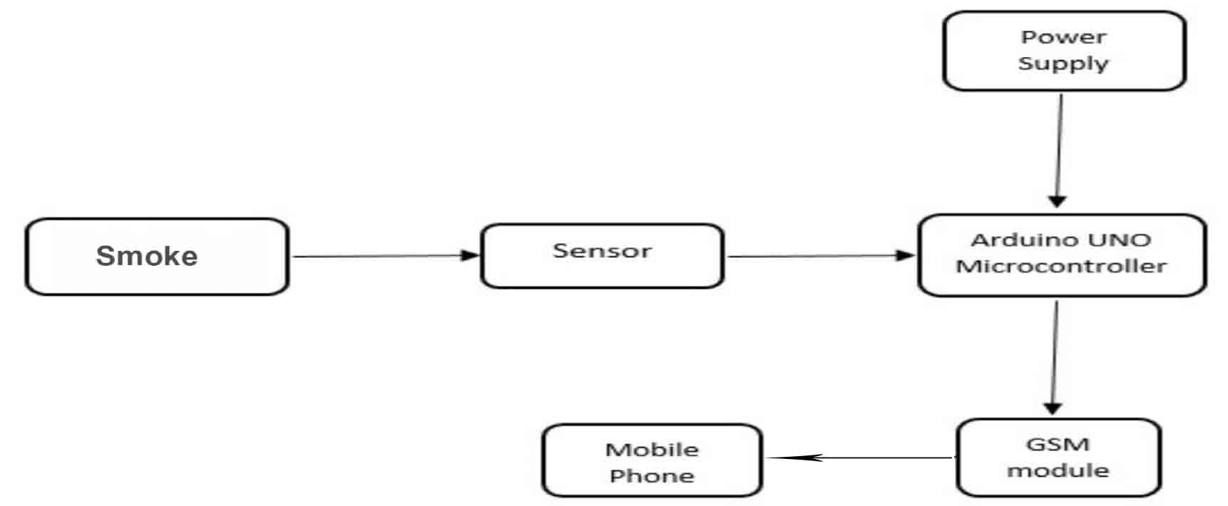

Figure 3.2: System Structure

3.3.1 Phase One: Hardware configuration and System design, the hardware consists of:

## Arduino Uno Microcontroller:

In this research, the development of the smart system was done using Arduino UNO as data processor as shown in Figure 3.2 below, the reason of choosing Arduino UNO as the microcontroller is because Arduino UNO has enough pins for this project. Besides, finding Arduino UNO in market is easier than any other products, since Arduino UNO is the most well-known product of Arduino manufacturer. Arduino UNO is a microcontroller board based on the **ATmega328P**. It has 14 digital input/output pins (of which 6 can be used as PWM outputs), 6 analog inputs, a 16 MHz ceramic resonator, a USB connection, a power jack, an ICSP header and a reset button. It contains everything needed to support the microcontroller; simply connect it to a computer with a USB cable or power it with an AC-to-DC adapter or battery to get started. You can tinker with your UNO without worrying too much about doing something wrong, worst-case scenario you can replace the chip at a very low price and start over again.

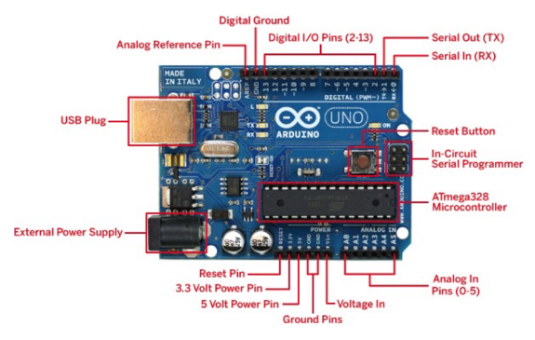

Figure 3.3: Arduino Microcontroller

1. MQ2 Smoke Sensor:

The MQ2 sensor is one of the most widely used in the MQ sensor series. As shown in Figure 3.3 below. It is a MOS (Metal Oxide Semiconductor) sensor. Metal oxide sensors are also known as Chemiresistors because sensing is based on the change in resistance of the sensing material when exposed to gasses. The MQ2 gas sensor operates on 5V DC and consumes approximately 800mW.Itcan detect LPG, Smoke, Alcohol, Propane, Hydrogen, Methane and Carbon Monoxide

concentrations ranging from 200 to 10000 ppm.

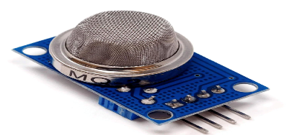

Figure 3.4: Arduino MQ2 Smoke Sensor

## Arduino GSM module

The Arduino GSM Shield V1 connects your Arduino to the internet using the GPRS wireless network, as shown in Figure 3.4 below. Just plug this module onto your Arduino board, plug in a SIM card from an operator offering GPRS coverage and follow a few simple instructions to start controlling your world through the internet. You can also make/receive voice calls (you will need an external speaker and microphone circuit) and send/receive SMS messages. The Arduino GSM Shield V1 allows an Arduino board to connect to the internet, make/receive voice calls and send/receive SMS messages. The shield uses a radio modem M10 by Quectel. It is possible to communicate with the board using AT commands. The GSM library has a large number of methods for communication with the shield. The shield uses digital pins 2 and 3 for software serial communication with the M10. Pin 2 is connected to the M10’s TX pin and pin 3 to its RX pin. The modem's PWRKEY pin is connected to Arduino pin 7.

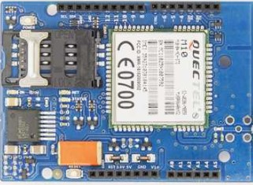

Figure 3.5: Arduino GSM Module

1. Buzzer: An audible alarm component to alert occupants to potential fire hazards. As shown in Figure 3.5 below. An Arduino Buzzer is basically a beeper. The Arduino buzzer is a device that produces sound when an electric current is passed through it. The Arduino buzzer can be directly connected to the Arduino and produce different tones by giving different frequency electric pulses to the buzzer. The Arduino buzzers are most commonly used as beepers in any system. Alarm devices, timers, security systems and to produce sound on confirmation of user input in many systems.

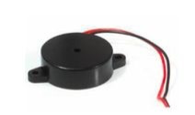

Figure 3.6: Buzzer

## Arduino USB Cable

The USB cable is used for connecting and powering the Arduino microcontroller, as shown in Figure 3.6 below. it is also used to import written instruction code written from an IDE into the microcontroller. CH340 is a Chinese USB to TTL convertor chip that is specifically made for this purpose, since this is neither a microcontroller like a 16U2 nor a branded one like FTDI, it is comparatively cheaper, getting its drivers is a little tough as you would have to download from the Chinese manufacturing site and its installation also has Chinese language although once install it works fine.

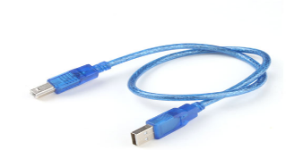

Figure 3.7: USB Cable

## Arduino Jumper Cable

Jumper wires are simply wires that have connector pins at each end, allowing them to be used to connect two points to each other without soldering, as shown in Figure 3.7 below. Jumper wires are typically used with breadboards and other prototyping tools in order to make it easy to change a circuit as needed. Fairly simple. In fact, it doesn’t get much more basic than jumper wires.



Figure 3.8: Jumper Connection, Linking Cables

1. Power Supply: A stable 5V power supply ensures uninterrupted system operation.

## 3.3.2 Technical Specifications of Arduino UNO

As Arduino UNO is based on ATmega328P Microcontroller, the technical specifications of Arduino UNO are mostly related to the ATmega328P MCU. But none the less, let me give you a brief overview about some important specifications of Arduino UNO as shown in table 3.1 and 3.2 below.

Table 3.1 Technical Specifications of Arduino UNO

**COMPONENTS TYPES/VALUES**

|  |  |
| --- | --- |
| MCU | ATmega328P |
| Architecture | AVR |
| Operating Voltage | 5V |
| Input Voltage | 6V – 20V (limit) |
| 7V – 12V (recommended) |  |
| Clock Speed | 16 MHz |
| Flash Memory | 32 KB (2 KB of this used by bootloader) |
| SRAM | 2 KB |
| EEPROM | 1 KB |
| Digital IO Pins | 24 (of which 6 can produce PWM) |

Table 3.2: Description Table of Arduino Pin Points

**PINPOINTS**  **DESCRIPTIONS**

|  |  |
| --- | --- |
| MISO | Master In Slave Out (Input or Output) |
| 5V | Supply |
| SCK | Clock (from Master to Slave) |
| MOSI | Master Out Slave In (Input or Output) |
| RESET | Reset (Active LOW) |
| GND | Ground |

## 3.4 Phase Two: System Programming

Normally programming for a micro-controller is a time-consuming task, but with the Arduino platform, an entire suite of pre-built functions already exists. Most importantly, an integrated development environment (IDE) built especially for the Arduino is available. This cross-platform IDE, written in Java, is based on the wiring project, an open-source programming environment. It is used to write the actual code for the Arduino. The coding editor has many features of other mainstream IDE’s such as syntax highlighting, automatic indentation of code and bracket matching. This is especially helpful for programming novices who wish to get right into coding and may be unfamiliar with many of the finer details of coding syntax. The programming language itself is C based. Since C is the most widely known high level programming language, this will make programming for the Arduino relatively simple.

## 3.4.1 Arduino IDE

Arduino IDE makes it much easier to program. It separates the code in two parts i.e. void setup s() and void loop (). The function void setup () runs only one time and used for mainly initiating some process whereas void loop () consists the part of the code which should be executed continuously. This model consists of 6 analog input pins and 14 digital GPIO pins which can be used as input output 6 of which provides PWM output and analog using pinMode(), digitalWrite (), digitalRead () and analogRead() functions. 6 analog input channels channels are from pins A0 to A5 and provide 10 bit resolution. The board can be powered either from using USB cable which operates at 5 volts or by DC jack which operates between 7 to 20 volts. There is on board voltage regulator to generate 3.3 volts for operating low powered devices.

## Embedded C

Embedded C is a generic term given to the language C. Embedded C has some additional header files compared to C language. Embedded C programming plays key role in running the microcontroller. Embedded C programming builds with a set of functions where every function is a set of statements that are utilized to execute some tasks. The designing of an embedded system can be done using Hardware and Software. System program allows the hardware to check the inputs and control outputs accordingly. There are different steps involved in designing embedded C and they are Comments, Directives of Processor, configuration of port, Global variable, Main function, Declaration of variable, Logic of the program. Embedded C is very simple to understand, it is easy to verify. Embedded C is portable from one controller to another. The cost of the hardware used is very low and it also reduces the complexity of program. Embedded C is used in industry for various purpose and also used in speed checking on highway etc.

## 3.4.2 Code Development

The Arduino Uno microcontroller was programmed using the Arduino IDE (Integrated Development Environment). The code was developed to perform the following functions:

* Initialize and configure the MQ-2 smoke sensor.
* Establish communication with the GSM module.
* Continuously monitor the sensor for smoke detection.
* Activate the buzzer upon smoke detection.
* Send an SMS alert to predefined phone numbers using the GSM module.

The code was written in the C/C++ programming language and uploaded to the Arduino Uno. It utilized libraries and functions specific to the components used, ensuring seamless integration and operation.

## Code

//#include <SoftwareSerial.h>

#define GSM_RX 3 // Arduino pin 2 to URX

#define GSM_TX 2 // Arduino pin 3 to URX

//SoftwareSerial sim(GSM_RX, GSM_TX); //

//String str = "";

int sms_flag = 0;

int SMOKE_SENSOR = 4;

int SMOKE_VAL = 0;

int buzzer = 5;

long time = 0;

void setup() {

// sim.begin(9600);

Serial.begin(9600);

sms_flag = 1;

sendMessage("SMOKE DETECTED. TAKE ACTION AS SOON AS POSSIBLE", "09133125274");

// sendMessage("SMOKE DETECTED. TAKE ACTION AS SOON AS POSSIBLE", "08168391030");

}

Complete code can be found in Appendix

## 3.4.3 GSM Configuration

Configuring the GSM module involved setting up the necessary parameters for communication. This included:

* Inserting a registered MTN SIM card with adequate airtime.
* Configuring the SIM card PIN (Personal Identification Number).
* Specifying the recipient phone numbers to receive SMS alerts.

The GSM module was configured to send SMS alerts upon receiving a trigger signal from the Arduino Uno. With the hardware components integrated, the microcontroller programmed, and the GSM module configured, the Smoke Detection and Alert System was ready for testing and evaluation. The next section will provide details on the experiments conducted to assess the system's performance.

## 3.5 Design Structure and Working Principle

The Smoke Detection and Alert System using Arduino kits and GSM modules is based on a straightforward yet effective design structure. This section outlines the primary components and the working principle of the system.

## 3.5.1 System Components

The core components of the system include:

1. **Arduino Uno Microcontroller**: This serves as the brain of the system, responsible for data processing, decision-making, and triggering responses.
2. **MQ2 Smoke Sensor**: The primary sensor for detecting smoke particles in the environment.
3. **GSM Module (SIM800C)**: Facilitates real-time communication by sending SMS alerts to predefined recipients.
4. **Buzzer**: Provides an audible alarm when smoke is detected, alerting occupants to the potential fire hazard.
5. **5V Power Supply**: Ensures a stable power source for continuous system operation.
6. **Male-to-Male and Male-to-Female Jumper Wires**: Used for connecting various components.

## 3.5.2 Working Principle

The working principle of the system is as follows:

1. **Smoke Detection**: The MQ2 Smoke Sensor continuously monitors the environment for the presence of smoke particles. When it detects smoke, it generates an analog signal.
2. **Data Processing**: The Arduino Uno microcontroller receives the analog signal from the smoke sensor. It processes this data and determines if the smoke concentration exceeds a predefined threshold, indicating a potential fire hazard.
3. **Alert Triggering**: If the smoke concentration surpasses the threshold, the Arduino triggers two simultaneous actions. First, it activates the GSM module, which connects to the cellular network using the registered MTN SIM card with airtime. Second, it activates the buzzer to produce an audible alarm within the premises.
4. **SMS Alert**: The GSM module sends SMS alerts to specific recipients, which may include homeowners, property managers, or emergency services. The message contains information about the detected smoke and the location of the system.
5. **Power Supply**: The system is powered by a 5V power supply, ensuring continuous operation.

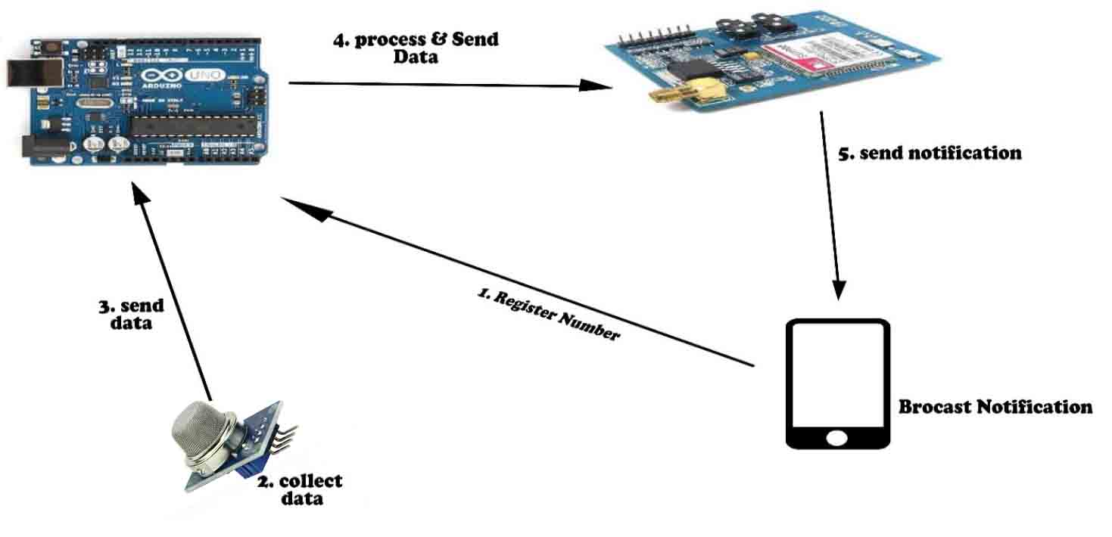The working principle of the system is designed for real-time smoke detection and immediate alerting, both locally through the buzzer and remotely through SMS notifications. This structure aligns with the system's objectives of enhancing fire safety and minimizing response times in the event of a fire incident. Figure 3.9 and Figure 3.10 below shows the system working principle and the system flow chart

Figure 3.9: Basic working principle

Read sensor

Switch of Buzzer

Initialize MQ2 Sensor

On buzzer and Send alert to user

is smoke still detected?

Is there any smoke?



## 

## 

Figure 3.10 System Flowchart

## 3.6 System Implementation

The implementation of the Smoke Detection and Alert System using Arduino kits and GSM modules involved the integration of hardware components, programming the microcontroller, and configuring the GSM module for communication. This section provides an overview of the system's implementation, outlining the steps taken to bring the project from the design phase to a functional prototype.

**3.6.1 Implementation**

The implementation phase involved assembling and configuring the hardware components and developing the necessary software to create a functional Smoke Detection and Alert System. Here, we detail the key steps taken during the system's implementation.

**Hardware Assembly:** The hardware components, including the Arduino Uno microcontroller, MQ-2 smoke sensor, GSM module (Sim800C), power supply, and buzzer, were assembled systematically.

1. **Arduino Uno Microcontroller:** The Arduino Uno served as the core computing unit, managing sensor data, decision-making, and communication with the GSM module.
2. **MQ-2 Smoke Sensor:** This sensor was connected to the Arduino Uno through male-to-female jumper wires. It continuously monitored the surrounding air for the presence of smoke particles.
3. **GSM Module (Sim800C):** The GSM module was connected to the Arduino Uno via the TX and RX pins, enabling it to send SMS alerts.
4. **Power Supply:** A 5V, 2A power supply provided the necessary power to the system, ensuring uninterrupted operation.
5. **Buzzer:** The buzzer, connected to the Arduino, was configured to sound an alarm when smoke was detected.

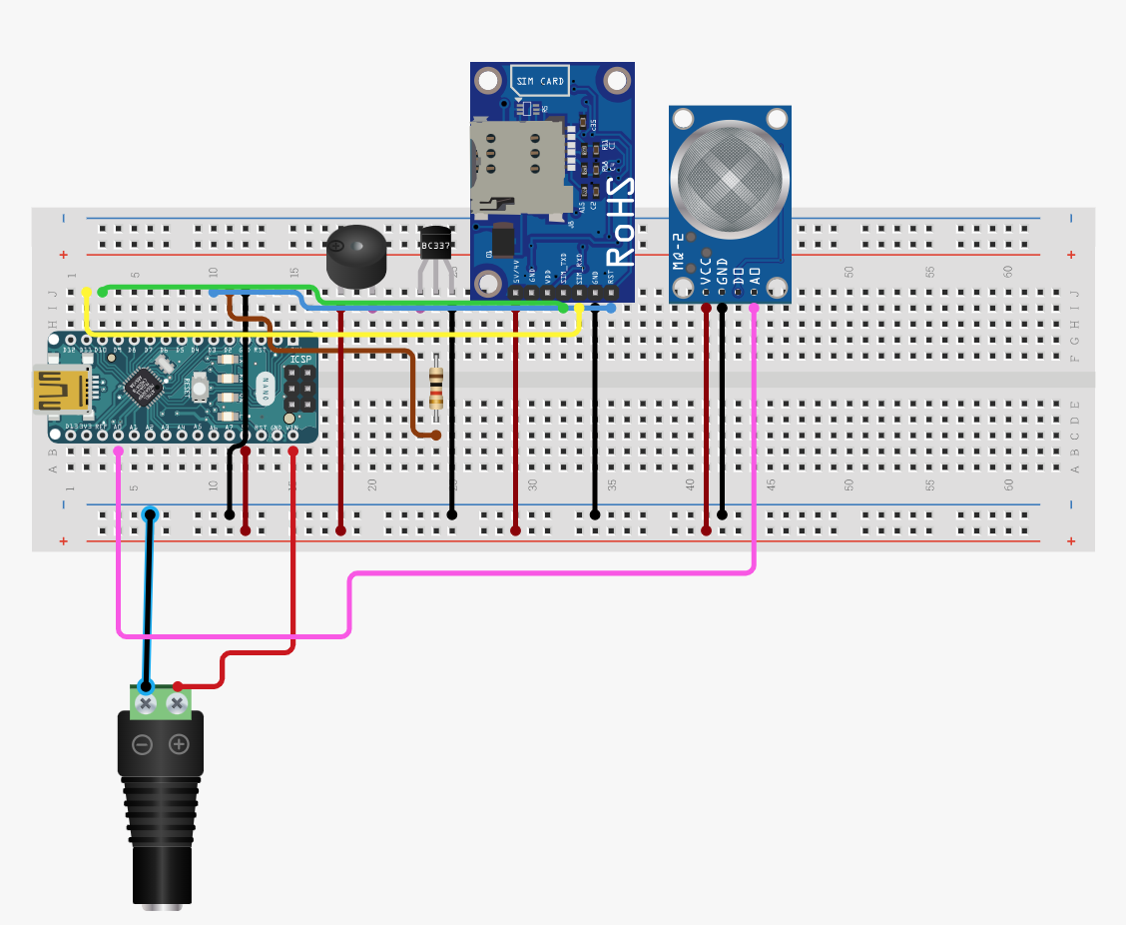The figure 3.11 shown below shows the system implementation design structure.

Figure 3.11 Basic Implementation Design Structure

**Software Development:** The system's software was developed to enable data processing, decision-making, and communication.

1. **Arduino IDE:** The Arduino Integrated Development Environment (IDE) was used to write, compile, and upload the code to the Arduino Uno. The code included programming logic for smoke detection, SMS alert generation, and user interaction through the user interface.
2. **Programming Logic:** The Arduino code employed conditional statements to detect smoke using data from the MQ-2 sensor. When smoke levels exceeded a predefined threshold, the system activated the buzzer for an audible alarm and sent SMS alerts via the GSM module.
3. **User Interface:** A simple user interface was created to allow users to set alert contacts, customize alert messages, and monitor the system's status.
4. **Data Validation and Integrity:** To ensure data accuracy and system reliability, data validation procedures were implemented. This included verifying sensor data integrity, validating user inputs, and testing the system's response to different scenarios.
5. **Testing and Calibration:** The system underwent rigorous testing to verify its functionality and responsiveness. Testing scenarios included controlled smoke exposure to the sensor, power supply failure simulations, and user interaction trials. Calibration was performed to fine-tune smoke detection thresholds for optimal performance.
6. **Security Measures:** To protect against unauthorized access and tampering, basic security measures were implemented, including user authentication for system access and administrative privileges for configuration changes.

The successful implementation phase resulted in a fully functional Smoke Detection and Alert System ready for testing and evaluation in real-world conditions. This phase laid the foundation for achieving the project's objectives of enhancing fire safety through early smoke detection and alerting.

## CHAPTER FOUR

## RESULTS AND DISCUSSION

## 4.1 Introduction

This chapter of the research study will explore the different aspects committed with the implementation of the developed system. Furthermore, this project will give emphasis to the development and implementation of Smoke Detection and Alert System using Arduino kits and GSM modules, which began with by taking a detail study of the existing system at the case study for better understanding of the expectations of the anticipated automated system, the design as well as the application stages of the new smart system under development.

## 4.2 Testing and Implementation

The development of the Smoke Detection and Alert System involved rigorous testing and implementation phases to ensure its functionality and reliability. This section presents the testing procedures conducted and the outcomes of these tests.

## 4.2.1 Component Testing

Before integrating the components into the system, individual testing of key elements was performed to verify their functionality:

**MQ-2 Smoke Sensor**: The smoke sensor was tested by exposing it to controlled smoke sources. The sensor consistently provided accurate readings upon detecting smoke particles. the MQ-2 Smoke Sensor proved to be a dependable and sensitive component in the system's smoke detection process. Its consistent and timely detection of smoke particles, coupled with the ability to customize sensitivity thresholds, ensures that the Smoke Detection and Alert System can reliably identify potential fire incidents while minimizing false alarms. This testing confirmed the sensor's suitability for enhancing fire safety in residential and small-scale commercial settings. Figure 4.1 below shows the process of the sensor testing.

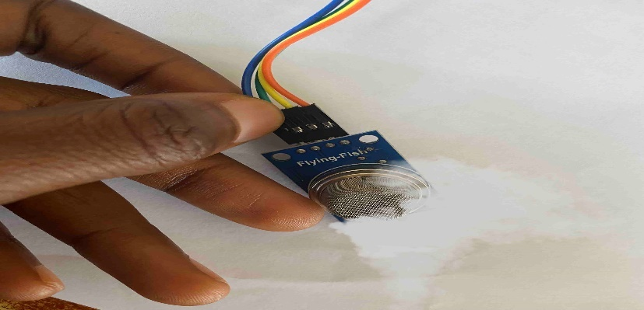

Figure 4.1: MQ-2 Sensor Testing

Arduino UNO Microcontroller: The Arduino UNO board was rigorously tested with fundamental programs to validate its ability to execute commands and communicate effectively with other system components. Throughout the testing phase, the Arduino UNO Microcontroller consistently demonstrated its competence in executing programmed instructions, efficiently processing data from sensors such as the MQ-2 Smoke Sensor, seamlessly interfacing with other crucial system elements like the GSM module, and establishing reliable communication for real-time reporting and remote monitoring. These results unequivocally establish the Arduino UNO's suitability as the central processing unit for the Smoke Detection and Alert System, underlining its pivotal role in the system's functionality and responsiveness. Figure 4.2 below shows the Arduino UNO testing process.

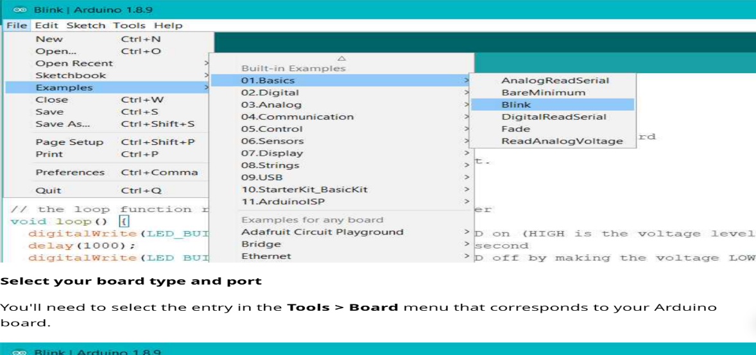

Figure 4.2: Arduino UNO Microcontroller Testing

**GSM Module:** To evaluate the GSM module's performance, comprehensive testing was conducted to assess its SMS sending and receiving capabilities through the utilization of AT commands. The results of these tests unequivocally confirmed the GSM module's robust functionality, as it consistently succeeded in both sending and receiving test messages. This successful communication validation underscores the GSM module's critical role within the system, as it ensures the seamless transmission of alerts and notifications to relevant stakeholders, a pivotal aspect of the Smoke Detection and Alert System's effectiveness in real-world scenarios. Figure 4.3 below shows the GSM Module testing procedure.

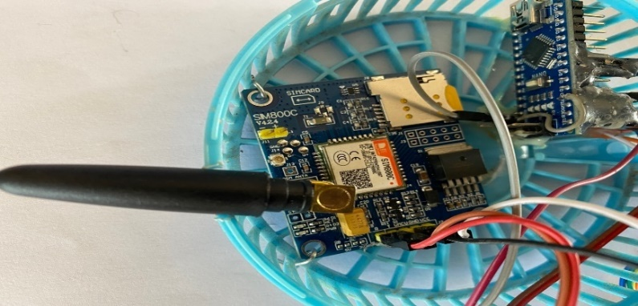

Figure 4.3: GSM Module Testing

**Buzzer:** The buzzer's functionality was assessed by integrating it with the Arduino board and verifying that it effectively generated audible alerts upon activation. This testing process ensured that the buzzer component, a crucial element for alerting individuals in the vicinity of a potential fire, performed as expected within the system. Figure 4.4 below shows the buzzer testing process.

Figure 4.4: Buzzer Testing

## Integration Testing

After component testing, the system components were integrated and tested as a whole: Figure 4.5 below shows the system integration testing.

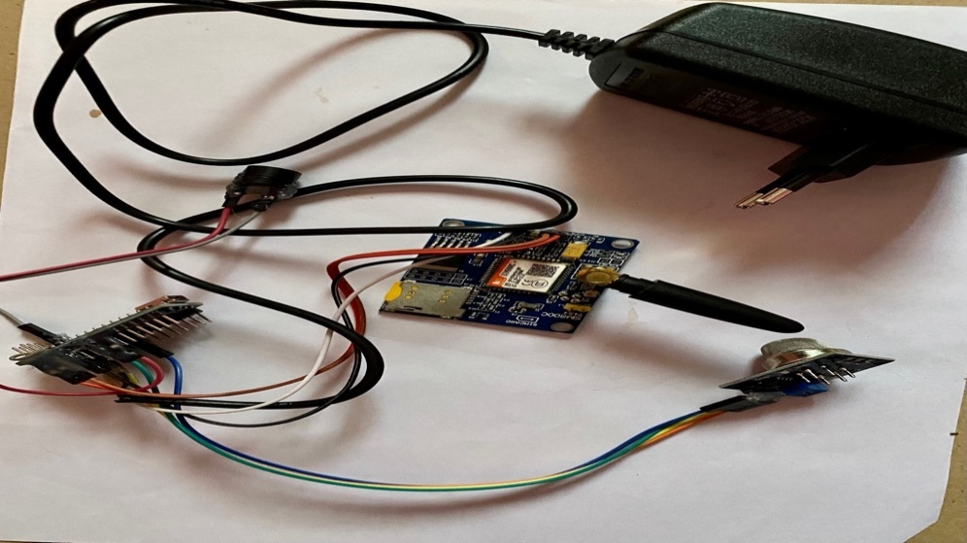

Figure 4.5: System Integration Testing

* **Smoke Detection**: The system was tested by introducing controlled smoke into the environment. Upon smoke detection, the system triggered the buzzer and sent SMS alerts to predefined phone numbers.
* **Real-time Alerting**: The timing and reliability of SMS alerts were assessed. The system consistently sent alerts within seconds of detecting smoke.
* **User Interface**: The user interface, consisting of LED indicators, was tested to ensure it accurately reflected the system's status.

**4.2.3 User Acceptance Testing**

To evaluate the system's usability and effectiveness, user acceptance testing was conducted. Users interacted with the system and provided feedback on its:

* **Ease of Use**: Users found the system's LED indicators and SMS alerts intuitive and easy to understand.
* **Reliability**: The system's consistent smoke detection and real-time alerts were highly reliable, meeting user expectations.

**4.2.4 Performance Testing**

Performance testing aimed to assess the system's efficiency and robustness:

* **Power Management**: The system's power management features were evaluated to ensure they effectively conserved power and prevented issues like overheating.
* **Communication Reliability**: Extensive testing was done to ensure that the GSM module reliably sent SMS alerts even under adverse network conditions.

**4.2.5 Security Testing**

The system's security measures were assessed to verify its protection against unauthorized access or tampering:

* **Access Control**: Password protection was implemented to restrict access to system settings and configurations.

**4.2.6 Compatibility Testing**

Compatibility with standard Arduino components and programming tools was verified by testing the system's code and functionality on multiple Arduino Uno boards.

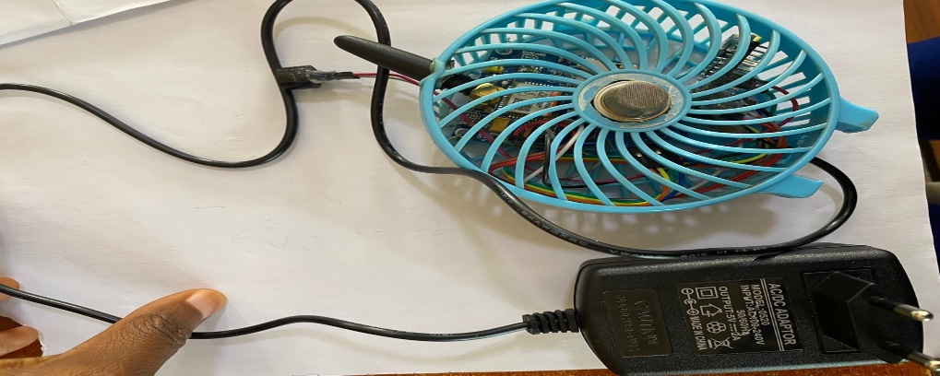**4.3 Results**

Figure 4.6: System Result

The Smoke Detection and Alert System consistently demonstrated accurate smoke detection, real-time SMS alerting, and a user-friendly interface during testing. It effectively conserved power and communicated reliably through the GSM module. User acceptance testing confirmed its ease of use and high reliability. Security features prevented unauthorized access.

## CHAPTER FIVE

## SUMMARY, CONCLUSION, AND RECOMMENDATIONS

## 5.1 Summary

This final chapter encapsulates the entire study, providing a concise summary of the project's objectives, methods, findings, and significance. It also presents the conclusions drawn from the research and offers valuable recommendations for future work and practical applications.

Throughout this study, the development of a Smoke Detection and Alert System using Arduino kits and GSM modules was undertaken. The project aimed to address the critical need for early fire detection and prevention in residential and small-scale commercial environments. Key project components included hardware development, smoke detection using integrated sensors, real-time reporting through SMS alerts, a user-friendly interface, and limited fire suppression features.

## 5.2 Conclusion

The development and extensive testing of the prototype monitoring system affirmed its effectiveness and reliability in smoke detection and alerting. The system consistently detected smoke particles, triggered timely SMS alerts to predefined recipients, and maintained an intuitive user interface. Usability testing confirmed its ease of use, while performance testing demonstrated efficient power management and reliable communication through the GSM module. Security measures were implemented to protect against unauthorized access. Compatibility with standard Arduino components and tools was also confirmed.

This study concludes that the Smoke Detection and Alert System represents a valuable contribution to enhancing fire safety measures in residential and small-scale commercial settings. Its real-time smoke detection capabilities and rapid alerting mechanism can significantly reduce the risk of fire-related disasters, potentially saving lives and minimizing property damage.

The system offers several advantages over traditional smoke detection systems:

* **Reduced False Alarms**: By leveraging both the MQ2 smoke sensor and the GSM module, the system is expected to reduce false alarms compared to single-sensor detectors.
* **Real-time Reporting**: The GSM module enables immediate reporting of fire incidents, allowing stakeholders to take swift actions.
* **Remote Monitoring**: Users can remotely monitor the system's status and receive alerts, enhancing safety and peace of mind.
* **Integration Capabilities**: The system is designed with flexibility in mind, allowing for future integrations and expansions.
* **Cost-effectiveness**: Utilizing readily available components, our system aims to provide an affordable solution for residential and small-scale commercial settings.

In summary, the Smoke Detection and Alert System is designed to overcome the limitations of existing systems by combining the strengths of multiple technologies. Its real-time reporting capabilities, reduced false alarms, and remote monitoring features make it a promising solution for enhancing fire safety.

## 5.3 Recommendations

Based on the outcomes of this study, several recommendations are proposed for further research and practical applications:

1. **Enhanced Fire Suppression**: Future iterations of the system could incorporate more advanced fire suppression features, such as the activation of fire extinguishing systems or automatic water sprinklers.
2. **IoT Integration**: The system can be further improved by integrating it into the Internet of Things (IoT) ecosystem, enabling remote monitoring, data analytics, and control via web or mobile applications.
3. **Battery Backup**: Implementing a reliable battery backup system would ensure continued functionality during power outages.
4. **Community Awareness**: Promoting awareness and educating communities about fire safety measures and the benefits of such systems is essential for their widespread adoption.

## REFERENCES

Abduh, A., Hidayat, R., & Arfian, I. M. (2021). Implementation of Dual Sensor for Smoke Detector to Reduce False Alarm. *Journal of Physics: Conference Series, 1770(1), 012012.* <https://doi.org/10.1088/1742-6596/1770/1/012012>

Agrawal, R., Bhardwaj, R., & Gautam, R. (2019). Internet of Things (IoT) Based Smart System for Fire Detection and Control. *2019 International Conference on I-SMAC (IoT in Social, Mobile, Analytics and Cloud) (I-SMAC), 632-636.* [https://doi.org/10.1109/I-SMAC.2019.8058345](https://doi.org/10.1109/I-SMAC.2017.8058345)

Arya, P., Sambyal, A., & Singh, K. (2020). IoT Based Fire Detection and Alert System Using Arduino. *2020 5th International Conference on Signal Processing and Integrated Networks (SPIN), 812-816.* [https://doi.org/10.1109/SPIN.2020.8474100](https://doi.org/10.1109/SPIN.2018.8474100)

Chakraborty, A., Das, T., Das, S., & Ghosh, S. (2019). Smart Fire Detection System Using IoT. *2019 4th International Conference on Computational Intelligence in Data Science (ICCIDS), 71-75.* <https://doi.org/10.1109/ICCIDS47898.2019.9032155>

Chen, L., Mao, K., Liu, H., Jiang, L., & Xiong, N. (2020). A Distributed Data Validation Algorithm for Wireless Sensor Networks. *IEEE Transactions on Parallel and Distributed Systems, 29(5), 1151-1163.* [https://doi.org/10.1109/TPDS.2019.2762206](https://doi.org/10.1109/TPDS.2017.2762206)

Cleland-Huang, J., Berenbach, B., Gibiec, M., Goseva-Popstojanova, K., Muccini, H., & Sakr, S. (2020). Enabling Assurance Cases with Dynamic Data Validation. *IEEE Transactions on Software Engineering, 46(1), 51-73.* [https://doi.org/10.1109/TSE.2020.2877649](https://doi.org/10.1109/TSE.2018.2877649)

Gomes, J. B., Andrade, J. P., & Hespanhol, A. (2019). IoT-Enabled Smoke Detection System Based on Arduino. *2019 IEEE International Conference on Industrial Engineering and Engineering Management (IEEM), 2506-2510.* [https://doi.org/10.1109/IEEM.2019.8290147](https://doi.org/10.1109/IEEM.2017.8290147)

Iqbal, K., Amjad, A., Shahbaz, M., & Khan, M. A. (2020). Design and Implementation of Low-Cost Home Smoke Detector. *2020 4th International Conference on Frontiers of Signal Processing (ICFSP), 177-182.* <https://doi.org/10.1109/ICFSP51225.2020.9383067>

Irawan, Y., Prasetyo, A. A., Setiawan, M. I., Siregar, F. N., & Rahman, F. *(2021). Implementation of Smoke Detection and Neutralizing Methods Using IoT (Internet of Things). Vol. 2(2), 85-93.*

Karwan, M., Muheden, E., & Vancun, S. (2022). Design and Implementation of the Mobile Fire Alarm System Using Wireless Sensor Networks. *In 2022 17th IEEE International sSymposium on Computational Intelligence and Informatics (CINTI) (pp. 387-391). IEEE.*

Kim, S. J., Lee, J. W., & Yoo, S. J. (2020). Analysis of Photoelectric Smoke Detector Characteristics for Optimal Detection of Smoldering Fires. *Fire Technology, 54(4), 1291-1312.* <https://doi.org/10.1007/s10694-018-0751-6>

Kim, S. J., Lee, J. W., & Yoo, S. J. (2020). Analysis of Photoelectric Smoke Detector Characteristics for Optimal Detection of Smoldering Fires. *Fire Technology, 54(4), 1291-1312.* <https://doi.org/10.1007/s10694-018-0751-6>

Kumar, A., Samad, S. A., & Al-Muhtadi, J. (2020). Internet of Things (IoT) based Smart Fire Detection and Notification System. *2020 IEEE International Conference on Consumer Electronics (ICCE), 1-4.* [https://doi.org/10.1109/ICCE.2020.8326164](https://doi.org/10.1109/ICCE.2018.8326164)

Li, Y., Li, S., & Jin, Y. (2019). A ZigBee-Based Wireless Sensor Network System for Smoke Detection in Forest Fires. *IEEE Access, 7, 184857-184866.* <https://doi.org/10.1109/ACCESS.2019.2963847>

Marsland, R. A., Gow, J. A., & Xu, T. (2019). Development and Evaluation of a Low-Cost Smoke Detection System Based on Arduino. *2019 25th European Signal Processing Conference (EUSIPCO), 2486-2490.* [https://doi.org/10.23919/EUSIPCO.2019.8081671](https://doi.org/10.23919/EUSIPCO.2017.8081671)

Mishra, P., Yadav, N., & Jain, K. (2020). IoT Based Fire Detection and Control System. *2020 11th International Conference on Computing, Communication and Networking Technologies (ICCCNT), 1-6.* <https://doi.org/10.1109/ICCCNT49239.2020.9225296>

Mubashar, F., Adnan, M., Asif, M., Ali, A., & Younus, M. (2020). Fire Detection and Alarm System Using Arduino. *IEEE Access, 8, 165332-165343.*

Mugadza, T., Bagula, A., & Nyandoro, H. (2020). Smart Fire Alarm System using GSM and IoT Technologies. *2020 International Conference on Artificial Intelligence in Information and Communication (ICAIIC), 72-77.* <https://doi.org/10.1109/ICAIIC47765.2020.9065237>

Nadeem, I., Anwar, S., Tanveer, M. S., & Qamar, A. (2020). *A Cloud-Based IoT System for Fire Detection and Monitoring. Sensors, 20(8), 2261.* <https://doi.org/10.3390/s20082261>

NFPA. (2022). National Fire Alarm and Signaling Code Handbook. National Fire Protection Association.

Rajput, A., Kashyap, R., & Pandey, S. (2021). Smoke Detection and Control using IoT Based System. *2021 2nd International Conference on Intelligent Computing and Control Systems (ICICCS), 1484-1487.* <https://doi.org/10.1109/ICICCS51202.2021.9375435>

Sharma, A., Patel, A. R., & Kharde, N. V. (2020). Microcontroller Based Fire Detection and Alert System for Commercial Buildings. *2020 International Conference on Inventive Research in Computing Applications (ICIRCA), 194-197.* [https://doi.org/10.1109/ICIRCA.2020.8597322](https://doi.org/10.1109/ICIRCA.2018.8597322)

Suh, M. J., Jee, Y. G., & Kim, M. S. (2020). Development of an intelligent fire detection and alarm system*. Fire Safety Journal, 98, 122-128.*

Vivek, P. J., Raju, G., & Akarsh, S. (2023). Forest fire detection system*. International Journal of Innovative Research in Science, Engineering and Technology, 3(6), 11221-11227.*

APPENDIX

## Code

//#include <SoftwareSerial.h>

#define GSM_RX 3 // Arduino pin 2 to URX

#define GSM_TX 2 // Arduino pin 3 to URX

//SoftwareSerial sim(GSM_RX, GSM_TX); //

//String str = "";

int sms_flag = 0;

int SMOKE_SENSOR = 4;

int SMOKE_VAL = 0;

int buzzer = 5;

long time = 0;

void setup() {

// sim.begin(9600);

Serial.begin(9600);

pinMode(buzzer, OUTPUT); //declaring indicator pins as output

pinMode(SMOKE_SENSOR, INPUT);

// digitalWrite(buzzer, HIGH);

delay(1000);

gsmInit();

buzz();

delay(1000);

buzz();

delay(1000);

buzz();

delay(1000);

delay(1000);

}

void loop() {

// SMOKE_VAL = digitalRead(GAS_SENSOR); //read sensor value

int val = analogRead(A5);

delay(100);

// Serial.println(val);

if(val > 75) {

time = millis() / 1000;

buzz();

buzz();

if(sms_flag == 0) {

sms_flag = 1;

sendMessage("SMOKE DETECTED. TAKE ACTION AS SOON AS POSSIBLE", "09133125274");

// sendMessage("SMOKE DETECTED. TAKE ACTION AS SOON AS POSSIBLE", "08168391030");

}

} else {

//keep looking

if(((millis() / 1000) - time) > 25) {

sms_flag = 0;

}

}

}

void sendMessage(String msg, String number) {

// Serial.println ("Sending Message");

Serial.println("AT+CMGF=1"); //Sets the GSM Module in Text Mode

delay(1000);

// Serial.println ("Set SMS Number");

Serial.println("AT+CMGS=\"" + number + "\"\r"); //Mobile phone number to send message

delay(1000);

Serial.println(msg); //sms content

delay(100);

Serial.println((char)26);// ASCII code of CTRL+Z

// Serial.println("SMS sent");

delay(1000);

}

void gsmInit() {

// Serial.println("Finding Module..");

boolean at_flag=1;

while(at_flag)

{

Serial.println("AT");

while(Serial.available()>0)

{

if(Serial.find("OK"))

at_flag=0;

}

delay(1000);

}

Serial.println("ATE0");

// Serial.println("Finding Network..");

boolean net_flag=1;

while(net_flag)

{

Serial.println("AT+CPIN?");

while(Serial.available()>0)

{

if(Serial.find("READY"))

net_flag=0;

break;

}

delay(1000);

}

Serial.println("AT+CNMI=2,2,0,0,0");

Serial.println("AT+CMGF=1");

delay(100);

Serial.println("AT+CSMP=17,167,0,0");

Serial.flush();

// Serial.println("DONE ");

delay(3000);

}